Histogram Matching
Code:
import numpy as np
import cv2
import matplotlib.pyplot as plt

def histogram_matching(original_image, reference_image):
original_hist, _ = np.histogram(original_image.flatten(), bins=np.arange(6), density=True)
reference_hist, _ = np.histogram(reference_image.flatten(), bins=np.arange(6), density=True)

original_cdf = np.cumsum(original_hist)
reference_cdf = np.cumsum(reference_hist)

original_cdf_normalized = original_cdf / original_cdf.max()
reference_cdf_normalized = reference_cdf / reference_cdf.max()

original_mapping = np.round(original_cdf_normalized * 3).astype(int)
reference_mapping = np.round(reference_cdf_normalized * 3).astype(int)

matched_image = np.zeros_like(original_image)
for i in range(5):
matched_image[original_image == i] = reference_mapping[i]

return matched_image, original_mapping, reference_mapping

def plot_image_and_histogram(ax, image, title):
ax[0].imshow(image, cmap='gray', interpolation='nearest')
ax[0].set_title(title)
ax[1].hist(image.flatten(), bins=np.arange(6) - 0.5, edgecolor='black', density=True)
ax[1].set_title("Histogram")
ax[1].set_xlabel("Pixel Value")
ax[1].set_ylabel("Frequency")

original_image = cv2.imread('kop.jpg', cv2.IMREAD_GRAYSCALE)
reference_image = np.array([
[4, 3, 2, 3, 2],
[2, 2, 3, 4, 4],
[1, 2, 3, 2, 2],
[3, 3, 3, 1, 4],
[1, 2, 3, 4, 4]
])

matched_image, _, _ = histogram_matching(original_image, reference_image)

fig, axs = plt.subplots(3, 2, figsize=(18, 18))

plot_image_and_histogram(axs[0], original_image, "Original Image")
plot_image_and_histogram(axs[1], reference_image, "Reference Image")
plot_image_and_histogram(axs[2], matched_image, "Matched Image")

for i in range(3):
axs[i, 0].axis('off')

plt.tight_layout()
plt.show()
Code Explanation :
- Histogram Calculation:
  - np.histogram is used to compute the histograms of the original and reference images.
- CDF Calculation:
  - Cumulative distribution functions (CDFs) are computed using np.cumsum for both histograms.
- Normalization:
  - The CDFs are normalized to range from 0 to 1.
- Mapping:
  - Pixel values of the original image are mapped to match the reference image's histogram based on the normalized CDFs.
- Plotting:
  - The original image, reference image, and matched image, along with their histograms, are plotted using Matplotlib.
Output:
- A 3x2 grid showing the images and histograms before and after the matching process.

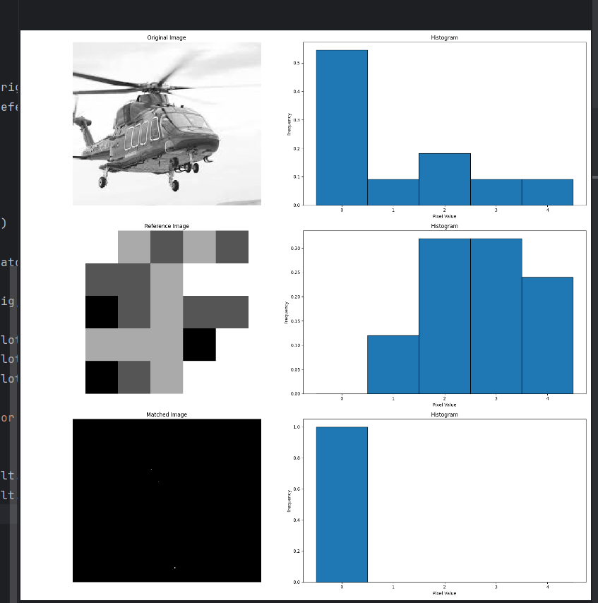
Output:

Report
Objective: The objective of this process is to adjust the pixel intensity distribution of an original image so that it matches the distribution of a reference image. This is done using histogram matching, a technique commonly used in image processing for enhancing or normalizing images.
Methodology:
- Input Images:
  - Original Image: The image whose histogram we want to match (grayscale image loaded using OpenCV).
  - Reference Image: A predefined image whose histogram the original image will be adjusted to match (provided as a small example in the code).
- Histogram Calculation:
  - The pixel intensity distribution of both images (original and reference) is computed using np.histogram(). This generates a histogram that shows the frequency of each intensity value.
- Cumulative Distribution Function (CDF):
  - The cumulative distribution functions (CDFs) are calculated for both the original and reference images. The CDF represents the cumulative probability of each pixel intensity, essentially showing the cumulative distribution of pixel values in the image.
- Normalization:
  - The CDFs are normalized so that their values lie between 0 and 1. This step ensures that both CDFs are on the same scale and can be compared.
- Histogram Matching:
  - The pixel values of the original image are mapped based on the CDF of the reference image. This is done by finding the closest match between the CDFs of the two images, transforming the pixel intensities of the original image to match the distribution of the reference image.
- Visualization:
  - The original image, reference image, and the resulting matched image are displayed, along with their histograms. This helps to visually assess the success of the histogram matching process.
Results:
The output consists of:
- Original Image: The image before histogram matching.
- Reference Image: The image whose histogram the original image is adjusted to.
- Matched Image: The image after applying histogram matching, where its pixel intensity distribution closely resembles that of the reference image.
Additionally, histograms for all three images are displayed, showing how the intensity distributions change before and after matching.

